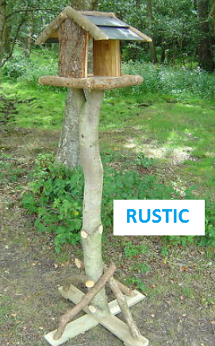
GARDEN BIRD TABLE DESIGNS
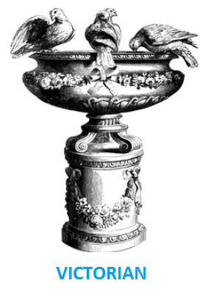
Bird tables and baths first become popular in Victorian times and are now available in many forms and can be categorized as follows:
- Traditional
- Rustic
- Modern
- Unique
They can be mounted in different ways:
- On top of a post or pillar
- Attached to a wall or tree trunk
- Suspended by a rope or chain
All products are designed to achieve one or more of the following goals:
- Provide food
- Provide water
- Provide shelter
- Provide an platform that is safe from predictors
- Be an attractive garden ornament
- Provide interest and education to home owners
The RSPB emphasizes the importance of providing water to the survival of small birds and in many ways this as important as food:
- “Birds need water for drinking and bathing. Water is particularly important during the winter when natural supplies may be frozen and in dry, hot weather during the summer when water can be hard to find.”
- “Birds have no sweat glands, so they need less water than mammals. However, they do lose water through respiration, and in their droppings. Most small birds need to drink at least twice a day to replace the lost water.”
- “Water to bathe in is just as important for birds, especially in winter. It is essential that they keep their feathers in good condition, and bathing is an important part of feather maintenance”

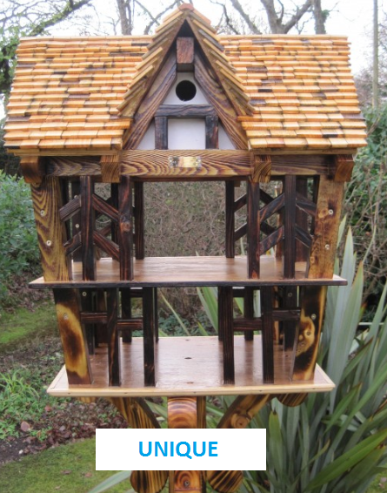
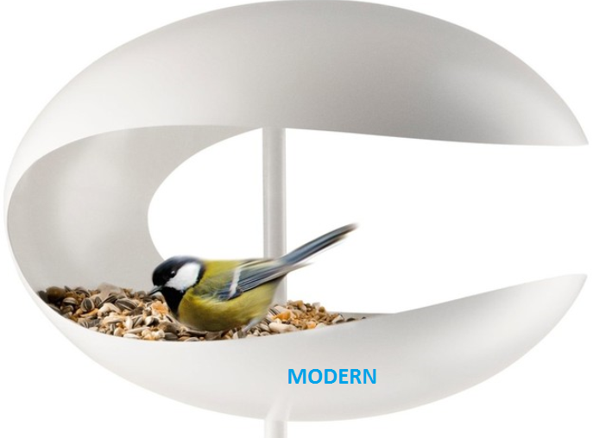
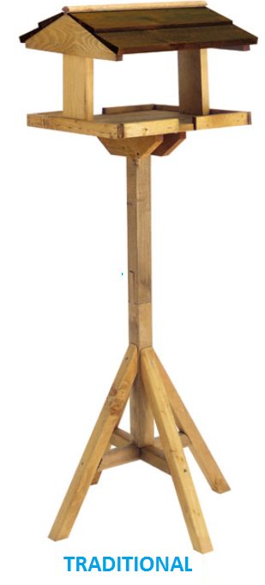

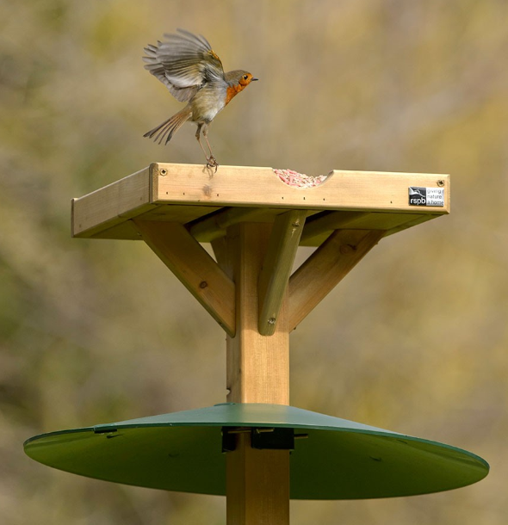
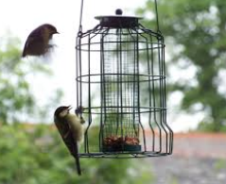
GARDEN BIRD TABLES – KEEPING AWAY UNWANTED VISITORS

Squirrels are well known for their cunning and acrobatic feats in their quest for bird food. A wood pigeon typically weights 20 times as much as a small bird and will rapidly consume all food put out on a table.
Bird table manufacturers have come up with many ways for stopping these unwanted visitors getting to the bird food. Owners have also tried to do the same. In many cases they have not been very successful!
The approaches used usually fall into one of two categories:
- Surrounding feeding area with cages that only allow access to small birds. The approach works well against large birds and squirrels , but can put off small birds because they feel trapped
- Placing “umbrellas” on posts or over suspension ropes. This can prevent squirrels getting to the food but has no effect on large birds
There does not seem to be any electronic based solutions to the problem available from commercial manufactures. Squirrel repellers that use high frequency sound are sold but are not designed with birds in mind and will also keep them away.
With the widespread availability of cheap microprocessor boards and components there seems to be a gap in the market.

